**Message Creation & Validation Tool**

Business Requirements Specification

Version 0.5

|  |  |  |
| --- | --- | --- |
| **DOCUMENT VERSION CONTROL** | | |
| **Document Title** | Message Creation & Validation Tool | |
| **Version** | Draft version – 0.5 | |
| **Date Issued** |  | |
| **Status** |  | |
| **Location** | Chennai, India | |
| **Author** | Charanraj Narsu | |
| **Reviewers** | **Date** | **Comments** |
| **Raajesh** | 28-05-2019 | Changes incorporated :Background,Objective, configuration set up & High Level Requirement |
| **Sunil** | 28-05-2019 |  |

|  |  |  |  |
| --- | --- | --- | --- |
| **DOCUMENT VERSION HISTORY** | | | |
| **Date** | **Version** | **Author** | **Details of Changes** |
| 15-05-2019 | 0.1 | Charanraj Narsu | Draft Version |
| 26-05-2019 | 0.2 | Charanraj Narsu | Incorporating the flow/approach as per the discussion with Raajesh, Sunil |
| 26-05-2019 | 0.3 | Raajesh | Changes incorporated :Background,Objective, configuration set up & High Level Requirement |
| 26-05-2019 | 0.4 | Sebastian | Included the Technical specification and approach |
| 14-06-2019 | 0.5 | Raajesh | Included reference for Pain,pacs & camt messages |

1. **Background**

The Payment Message Types form the heart of the financial ecosystem,which underlines the required infrastructure for High Value Payments Real Time Gross Settlement (RTGS) systems, Low Value Payments Automated Clearing Houses (ACHs) and Real-Time Retail Payment Systems. Major Central Banks such as the Federal Reserve and The Clearing House (US), Eurosystem and EBA Clearing (Eurozone) and the Bank of England’s RTGS (UK) have plans to modernise their High Value Payment Systems (HVPS), almost simultaneously. Underpinning each of those modernisation programs is the migration to ISO 20022, widely recognised as the standard for the future. Indeed, ISO 20022 has already been introduced for HVPS in Japan, Switzerland and China, and is established as the de facto standard in instant payments markets following implementations in Australia, US, Canada and Singapore. SWIFT will also introduce ISO 20022 for cross-border payments, with a view to phasing out existing payment messages.

1. **Introduction**

Keeping the evolution of the ISO 20022 messages , we at Expleo have taken the steps to forsee and a develop a tool which can generate and validate the ISO 20022 messages in specific to PACS,PAIBN and Camt,which could be deployed across Geographies The first phase for the tool development involves the generation of the ISO 20022 messages catering to PACS,PAIN and Camt

The second phase for the tool development would cater to the validation of the messages and then the tool would be extended to provide an ack/Nack based on the network requirement.

The tool could also be extended to convert a SWIFT MT to an ISO 20022 message format.

The tool would be a wed based tool and internally developed by Expleo , Chennai.

1. **Tool Feature.**

Web based tool will consist of following features.

Creation (Phase 1):-

1. Select the required message type.
2. Complete the mandatory information.
3. Validate the message as per the standard.
4. Generate output file/message

Upload a message(Phase 2):-

1. Upload a message in excel/Notepad
2. Validate the message as per the standard.
3. Generate output file If required.

Search & retrieve existing message(Phase 1):-

1. Search an existing message stored in DB
2. Edit the data if required.
3. Validate the message as per the standard.
4. Generate output file if required.

Provide Ack/Nack(Phase 3):-

1. Upload /Create a message
2. Validate the message as per the standard.
3. Generate output file If required.
4. Provide Ack/Nack as per network standards.
5. **Scope of the tool for Phase-1:**
6. creation of Message.
7. Retrieve existing message from DB.
8. **Out of Scope for Phase 1**
9. Message injection in MQ or other external tool.
10. Automatic Validation of Payment application file and providing ACK/NACK services.

1. **Expected Configuration of the tool**

* The toll is expected to cater to all ISO 20022 message formats , in effect the tool should have a repository of all the tags pertaining to ISO 20022 built in.
* The tool would be provided the latest XSD files for the different formats of the message(Pain or Pacs or Camt) for making it understand the different message types involves and ineffect to map the map the tags from the built in repository to the varius message formats.
* The tool would alsoo be provided with the individual ISO tag to front end field mapping (like for example <DbtrAcct><Id><IBAN> to Debtor Account number field).
* We may extend the tool to cater to the conversion of SWIFT MT’s to ISO 20022 based on the above points.

The mapping and in turn the selection process of messages to generate a valid message is given below

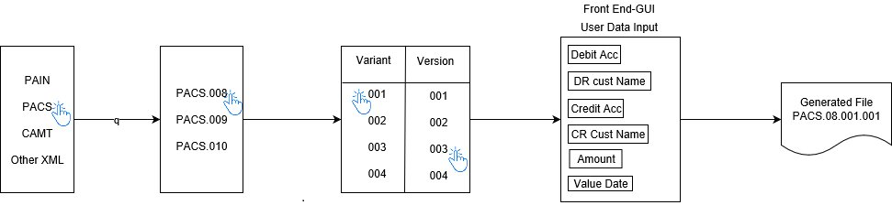

1. **Flow Diagram**





8. 1. **Message Generation Flow.**

User generate’s a new message from the tool and initiate the message in the application. Example Pain.008 generated from tool and inject in application for testing.

**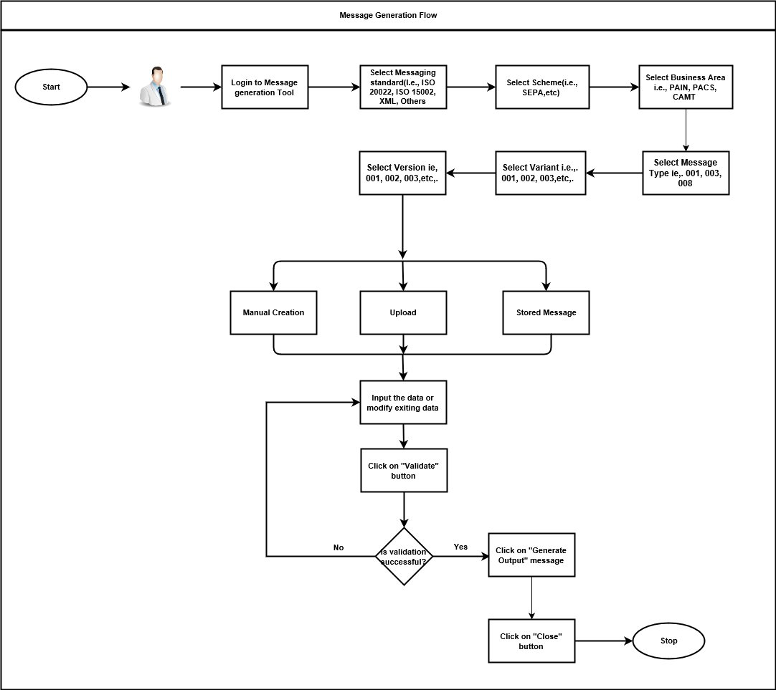**

* 1. **Message Validation Flow (Phase 2)**

User upload’s an outgoing message generated by Banking application and validate the message as per the standard. Example, Outgoing PACS.003.001.003 generated by payment application will be validated by the tool as per the standard.

**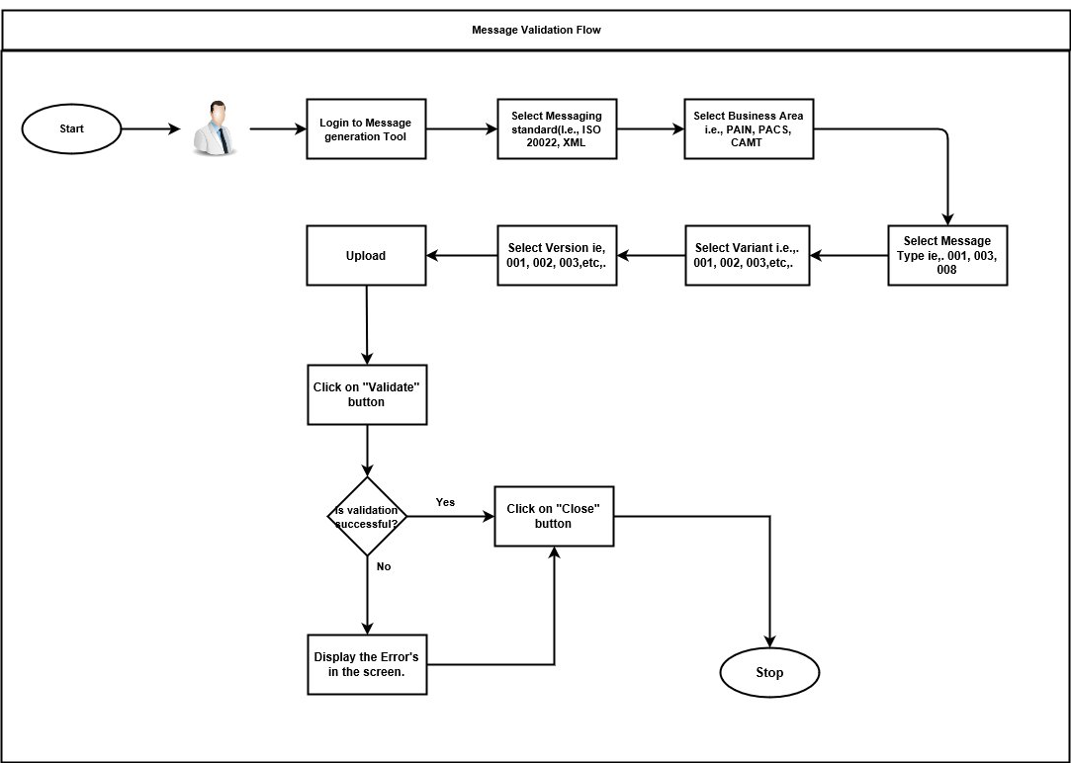**

1. **High Level requirements**

|  |  |  |  |
| --- | --- | --- | --- |
| **Req. ID** | **Requirement Description** | **Priority** | **Must/Need/Nice to Have** |
| OP001 | The various message type pertaining to ISO 20022 should be generated by the tool   * + - PACS     - PAIN     - Camt |  |  |
| OP002 | The Tool is a web based tool with GUI screens for completing the required functions. |  |  |
| OP003 | User should be able to complete the details prompted by the GUI to generate the expected message type , version and variant. | Phase 1 |  |
| OP004 | User should be able to upload a message in to the tool which in turn should be displayed at the corresponding mapped fields in the GUI depending on the message Type , Version and Variant | Phase 2 |  |
| OP005 | The tool should also be able to validate a message type when its uploaded . | Phase 2 |  |
| OP006 | The tool should be capable of displaying a report based on number of messages generated , type of message generated. |  |  |
| OP007 | The tool should be capable of retrieve an already created message for future use, in effect the tool should store the messages which has been generated/uploaded. |  |  |
| OP008 | The tool is expected to hold all kinds of tags which are associated with ISO 20022 format |  |  |
| OP009 | The tool would be expected to recognise a ISO 20022 format from a given template, these templates according to the message type, version and variant would be provided to the development team to configure the expected message types to be generated/validated. |  |  |
| OP010 | The complete workflow from selection to creation /rejection needs to be tracked and recorded |  |  |
| OP011 | An audit trail is expected to be provided for each selection made, screen traversed, creation or rejection of messages. |  |  |
| OP012 | Only the admin user should be able to tweak the configuration at the back end at any given time. |  |  |

**9. Technical Specification and approach**

**9.1 Technical Specification**

* The tool is going to be developed as a web page
* Programming Language used – C# , ASP
* Scripting Language – Javascript, Angular JS
* Database – SQS server express
* Webserver – IIS
  1. **High Level Approach**

**The tool has 3 main pages**

### **ISO Template page**

* The details from the ISO templates (XSD) for all the messages are stored in the database using this page
* User select the path where the XSD file is located
* The tool picks up the XSD file and stores the tag, type and condition details into the database by reading the complete XSD file

### **Configuration page**

* Any new message format should be configured before it is used by the particular bank to generate the message
* The user provides the details of the message which he want configure for the bank ( example : Message standard,Variant,Verison.. etc)
* The tool displays all the tags for the particular message type based on the details saved in the ISO Template page
* The tags which is applicable to the bank is selected by the user
* The details are stored into the database with the bank name

### **Message Generation page**

* User input the following details

Message type, Version, Path where file to be generated

* After input the above details, user form will be displayed based on the message type, version. The tags which is applicable to the particular bank will be displayed to the user based on the input provided by the user in the Configuration page
* User inputs the values for all the tags.
* The rules (including mandatory and non-mandatory) which needs to be followed for that particular tag will be displayed to the user. This would help the user to input the correct values.
* Validations will be done after inputting the value for each tag
* When the user clicks the generate button, the XML file will be generated and stored in the location specified by the user

**10. Tool Design Model**

**Please refer the attached file for the design model of the tool**



* The tool would be provided the latest XSD files for the different formats of the message(Pain or Pacs or Camt) for making it understand the different message types involves and ineffect to map the map the tags from the built in repository to the various message formats.
* The tool would also be provided with the individual ISO tag to front end field mapping (like for example <DbtrAcct><Id><IBAN> to Debtor Account number field).
* The definition and the structure of the required ISO 20022 XML formats is referred from
* <https://www.iso20022.org/payments_messages.page>
* The above page will list out all kinds of Messages involved along with the specificiations.
* In this phase the main focus would be on the three type of Messages
  + - * + -PACS
        + -PAIN
        + -CAMT

**PACS-Payments Clearing and Settlement**

|  |  |  |
| --- | --- | --- |
| **Message Name** | **Msg ID (Schema)** | **Msg Def Report** |
| FIToFIPaymentStatusReportV10 | [pacs.002.001.10](https://www.iso20022.org/sites/default/files/documents/messages/pacs/schemas/pacs.002.001.10.zip) | [MDR](https://www.iso20022.org/sites/default/files/documents/general/ISO20022_MDR_PaymentsClearingAndSettlement_2018_2019.zip) |
| FIToFICustomerDirectDebitV08 | [pacs.003.001.08](https://www.iso20022.org/sites/default/files/documents/messages/pacs/schemas/pacs.003.001.08.zip) |
| PaymentReturnV09 | [pacs.004.001.09](https://www.iso20022.org/sites/default/files/documents/messages/pacs/schemas/pacs.004.001.09.zip) |
| FIToFIPaymentReversalV09 | [pacs.007.001.09](https://www.iso20022.org/sites/default/files/documents/messages/pacs/schemas/pacs.007.001.09.zip) |
| FIToFICustomerCreditTransferV08 | [pacs.008.001.08](https://www.iso20022.org/sites/default/files/documents/messages/pacs/schemas/pacs.008.001.08.zip) |
| FinancialInstitutionCreditTransferV08 | [pacs.009.001.08](https://www.iso20022.org/sites/default/files/documents/messages/pacs/schemas/pacs.009.001.08.zip) |
| FinancialInstitutionDirectDebitV03 | [pacs.010.001.03](https://www.iso20022.org/documents/messages/pacs/schemas/pacs.010.001.03.zip) |
| FIToFIPaymentStatusRequestV03 | [pacs.028.001.03](https://www.iso20022.org/sites/default/files/documents/messages/pacs/schemas/pacs.028.001.03.zip) |

**Payments Initiation-Pain**

|  |  |  |
| --- | --- | --- |
| **Message Name** | **Msg ID (Schema)** | **Msg Def Report** |
| CustomerCreditTransferInitiationV09 | [pain.001.001.09](https://www.iso20022.org/sites/default/files/documents/messages/pain/schemas/pain.001.001.09.zip) | [MDR](https://www.iso20022.org/sites/default/files/documents/general/ISO20022_MDR_PaymentsInitiation_2018_2019.zip" \o "ISO 20022 MDR for the Payments Initiation (2016)" \t "_parent) |
| CustomerPaymentStatusReportV10 | [pain.002.001.10](https://www.iso20022.org/sites/default/files/documents/messages/pain/schemas/pain.002.001.10.zip) |
| CustomerPaymentReversalV09 | [pain.007.001.09](https://www.iso20022.org/sites/default/files/documents/messages/pain/schemas/pain.007.001.09.zip) |
| CustomerDirectDebitInitiationV08 | [pain.008.001.08](https://www.iso20022.org/sites/default/files/documents/messages/pain/schemas/pain.008.001.08.zip) |

Payment Mandates -Pain

|  |  |  |
| --- | --- | --- |
| **Message Name** | **Msg ID (Schema)** | **Msg Def Report & MUG** |
| MandateInitiationRequestV06 | [pain.009.001.06](https://www.iso20022.org/sites/default/files/documents/messages/pain/schemas/pain.009.001.06.zip" \t "_parent) | [MDR](https://www.iso20022.org/sites/default/files/documents/general/ISO20022_MDR_PaymentsMandates_2018_2019.zip" \t "_parent) |
| MandateAmendmentRequestV06 | [pain.010.001.06](https://www.iso20022.org/sites/default/files/documents/messages/pain/schemas/pain.010.001.06.zip" \t "_parent) |
| MandateCancellationRequestV06 | [pain.011.001.06](https://www.iso20022.org/sites/default/files/documents/messages/pain/schemas/pain.011.001.06.zip" \t "_parent) |
| MandateAcceptanceReportV06 | [pain.012.001.06](https://www.iso20022.org/sites/default/files/documents/messages/pain/schemas/pain.012.001.06.zip" \t "_parent) |
| MandateCopyRequestV02 | [pain.017.001.02](https://www.iso20022.org/sites/default/files/documents/messages/pain/schemas/pain.017.001.02.zip) |
| MandateSuspensionRequestV02 | [pain.018.001.02](https://www.iso20022.org/sites/default/files/documents/messages/pain/schemas/pain.018.001.02.zip) |

Cash Management -camt

|  |  |  |
| --- | --- | --- |
| **Message Name** | **Msg ID (Schema)** | **Msg Def Report** |
| GetAccountV07 | [camt.003.001.07](https://www.iso20022.org/sites/default/files/documents/messages/camt/schemas/camt.003.001.07.xsd" \t "_parent) | [MDR](https://www.iso20022.org/sites/default/files/documents/general/ISO20022_MDR_CashManagement.zip" \t "_parent) |
| ReturnAccountV08 | [camt.004.001.08](https://www.iso20022.org/documents/messages/camt/schemas/camt.004.001.08.xsd" \t "_parent) |
| GetTransactionV08 | [camt.005.001.08](https://www.iso20022.org/documents/messages/camt/schemas/camt.005.001.08.xsd" \t "_parent) |
| ReturnTransactionV08 | [camt.006.001.08](https://www.iso20022.org/documents/messages/camt/schemas/camt.006.001.08.xsd" \t "_parent) |
| ModifyTransactionV08 | [camt.007.001.08](https://www.iso20022.org/documents/messages/camt/schemas/camt.007.001.08.xsd" \t "_parent) |
| CancelTransactionV08 | [camt.008.001.08](https://www.iso20022.org/documents/messages/camt/schemas/camt.008.001.08.xsd" \t "_parent) |
| GetLimitV07 | [camt.009.001.07](https://www.iso20022.org/documents/messages/camt/schemas/camt.009.001.07.xsd" \t "_parent) |
| ReturnLimitV08 | [camt.010.001.08](https://www.iso20022.org/documents/messages/camt/schemas/camt.010.001.08.xsd" \t "_parent) |
| ModifyLimitV07 | [camt.011.001.07](https://www.iso20022.org/documents/messages/camt/schemas/camt.011.001.07.xsd" \t "_parent) |
| DeleteLimitV07 | [camt.012.001.07](https://www.iso20022.org/documents/messages/camt/schemas/camt.012.001.07.xsd" \t "_parent) |
| GetMemberV04 | [camt.013.001.04](https://www.iso20022.org/documents/messages/camt/schemas/camt.013.001.04.xsd" \t "_parent) |
| ReturnMemberV04 | [camt.014.001.04](https://www.iso20022.org/documents/messages/camt/schemas/camt.014.001.04.xsd" \t "_parent) |
| ModifyMemberV04 | [camt.015.001.04](https://www.iso20022.org/documents/messages/camt/schemas/camt.015.001.04.xsd" \t "_parent) |
| GetCurrencyExchangeRateV04 | [camt.016.001.04](https://www.iso20022.org/documents/messages/camt/schemas/camt.016.001.04.xsd" \t "_parent) |
| ReturnCurrencyExchangeRateV04 | [camt.017.001.04](https://www.iso20022.org/documents/messages/camt/schemas/camt.017.001.04.xsd" \t "_parent) |
| GetBusinessDayInformationV05 | [camt.018.001.05](https://www.iso20022.org/documents/messages/camt/schemas/camt.018.001.05.xsd" \t "_parent) |
| ReturnBusinessDayInformationV07 | [camt.019.001.07](https://www.iso20022.org/documents/messages/camt/schemas/camt.019.001.07.xsd" \t "_parent) |
| GetGeneralBusinessInformationV04 | [camt.020.001.04](https://www.iso20022.org/documents/messages/camt/schemas/camt.020.001.04.xsd" \t "_parent) |
| ReturnGeneralBusinessInformationV06 | [camt.021.001.06](https://www.iso20022.org/documents/messages/camt/schemas/camt.021.001.06.xsd" \t "_parent) |
| BackupPaymentV07 | [camt.023.001.07](https://www.iso20022.org/documents/messages/camt/schemas/camt.023.001.07.xsd" \t "_parent) |
| ModifyStandingOrderV06 | [camt.024.001.06](https://www.iso20022.org/documents/messages/camt/schemas/camt.024.001.06.xsd" \t "_parent) |
| ReceiptV05 | [camt.025.001.05](https://www.iso20022.org/documents/messages/camt/schemas/camt.025.001.05.xsd" \t "_parent) |
| GetReservationV05 | [camt.046.001.05](https://www.iso20022.org/documents/messages/camt/schemas/camt.046.001.05.xsd" \t "_parent) |
| ReturnReservationV06 | [camt.047.001.06](https://www.iso20022.org/documents/messages/camt/schemas/camt.047.001.06.xsd" \t "_parent) |
| ModifyReservationV05 | [camt.048.001.05](https://www.iso20022.org/documents/messages/camt/schemas/camt.048.001.05.xsd" \t "_parent) |
| DeleteReservationV05 | [camt.049.001.05](https://www.iso20022.org/documents/messages/camt/schemas/camt.049.001.05.xsd" \t "_parent) |
| LiquidityCreditTransferV05 | [camt.050.001.05](https://www.iso20022.org/documents/messages/camt/schemas/camt.050.001.05.xsd" \t "_parent) |
| LiquidityDebitTransferV05 | [camt.051.001.05](https://www.iso20022.org/documents/messages/camt/schemas/camt.051.001.05.xsd" \t "_parent) |
| GetStandingOrderV03 | [camt.069.001.03](https://www.iso20022.org/documents/messages/camt/schemas/camt.069.001.03.xsd" \t "_parent) |
| ReturnStandingOrderV04 | [camt.070.001.04](https://www.iso20022.org/documents/messages/camt/schemas/camt.070.001.04.xsd" \t "_parent) |
| DeleteStandingOrderV03 | [camt.071.001.03](https://www.iso20022.org/documents/messages/camt/schemas/camt.071.001.03.xsd" \t "_parent) |

Bank Services Billing-camt

|  |  |  |
| --- | --- | --- |
| **Messsage Name** | **Msg ID (Schema)** | **Msg Def Report & MUG** |
| BankServicesBillingStatementV03 | [camt.086.001.03](https://www.iso20022.org/documents/messages/camt/schemas/camt.086.001.03.zip" \t "_parent) | [MDR](https://www.iso20022.org/sites/default/files/documents/general/ISO20022_MDR_BankServicesBilling_2018_2019.zip" \o "BSB Message Definition Report" \t "_parent) [MUG](https://www.iso20022.org/documents/messages/camt/implementations/camt.086.001.01_MUG.zip) |

**Exceptions and Investigations-camt**

|  |  |  |
| --- | --- | --- |
| **Message Name** | **Msg ID (Schema)** | **Msg Def Report** |
| UnableToApplyV07 | [camt.026.001.07](https://www.iso20022.org/sites/default/files/documents/messages/camt/schemas/camt.026.001.07.zip) | [MDR](https://www.iso20022.org/sites/default/files/documents/general/ISO20022_MDR_ExceptionsAndInvestigations_2018_2019.zip" \t "_parent) |
| ClaimNonReceiptV07 | [camt.027.001.07](https://www.iso20022.org/sites/default/files/documents/messages/camt/schemas/camt.027.001.07.zip) |
| AdditionalPaymentInformationV09 | [camt.028.001.09](https://www.iso20022.org/sites/default/files/documents/messages/camt/schemas/camt.028.001.09.zip" \t "_parent) |
| ResolutionOfInvestigationV09 | [camt.029.001.09](https://www.iso20022.org/sites/default/files/documents/messages/camt/schemas/camt.029.001.09.zip" \t "_parent) |
| NotificationOfCaseAssignmentV05 | [camt.030.001.05](https://www.iso20022.org/documents/messages/camt/schemas/camt.030.001.05.zip) |
| RejectInvestigationV06 | [camt.031.001.06](https://www.iso20022.org/sites/default/files/documents/messages/camt/schemas/camt.031.001.06.zip) |
| CancelCaseAssignmentV04 | [camt.032.001.04](https://www.iso20022.org/documents/messages/camt/schemas/camt.032.001.04.zip) |
| RequestForDuplicateV06 | [camt.033.001.06](https://www.iso20022.org/sites/default/files/documents/messages/camt/schemas/camt.033.001.06.zip) |
| DuplicateV06 | [camt.034.001.06](https://www.iso20022.org/sites/default/files/documents/messages/camt/schemas/camt.034.001.06.zip) |
| ProprietaryFormatInvestigationV05 | [camt.035.001.05](https://www.iso20022.org/sites/default/files/documents/messages/camt/schemas/camt.035.001.05.zip) |
| DebitAuthorisationResponseV05 | [camt.036.001.05](https://www.iso20022.org/sites/default/files/documents/messages/camt/schemas/camt.036.001.05.zip) |
| DebitAuthorisationRequestV07 | [camt.037.001.07](https://www.iso20022.org/sites/default/files/documents/messages/camt/schemas/camt.037.001.07.zip) |
| CaseStatusReportRequestV04 | [camt.038.001.04](https://www.iso20022.org/documents/messages/camt/schemas/camt.038.001.04.zip) |
| CaseStatusReportV05 | [camt.039.001.05](https://www.iso20022.org/documents/messages/camt/schemas/camt.039.001.05.zip) |
| CustomerPaymentCancellationRequestV08 | [camt.055.001.08](https://www.iso20022.org/sites/default/files/documents/messages/camt/schemas/camt.055.001.08.zip" \t "_parent) |
| FIToFIPaymentCancellationRequestV08 | [camt.056.001.08](https://www.iso20022.org/sites/default/files/documents/messages/camt/schemas/camt.056.001.08.zip" \t "_parent) |
| RequestToModifyPaymentV06 | [camt.087.001.06](https://www.iso20022.org/sites/default/files/documents/messages/camt/schemas/camt.087.001.06.zip" \t "_parent) |

**Notification to Receive- camt**

|  |  |  |
| --- | --- | --- |
| **Message Name** | **Msg ID (Schema)** | **Msg Def Report** |
| NotificationToReceiveV06 | [camt.057.001.06](https://www.iso20022.org/documents/messages/camt/schemas/camt.057.001.06.zip" \t "_parent) | [MDR](https://www.iso20022.org/sites/default/files/documents/general/ISO20022_MDR_NotificationToReceive_2018_2019.zip" \o "ISO 20022 MDRs for Notification to Receive (2016)" \t "_parent) |
| NotificationToReceiveCancellationAdviceV06 | [camt.058.001.06](https://www.iso20022.org/documents/messages/camt/schemas/camt.058.001.06.zip" \t "_parent) |
| NotificationToReceiveStatusReportV06 | [camt.059.001.06](https://www.iso20022.org/documents/messages/camt/schemas/camt.059.001.06.zip" \t "_parent) |

* The Individual Banks/ Financial Institutions would have their own message template , which would be fed in to our tool , to recognize the tags present in that variant and to make the tool understand that particular variant is applicable only for that particular Bank.
* The third part of the approach is to make sure the applicable tags from a particular message type( PAIN,PACS and camt) is appearing on the front end screen to prompt the end user to key in the required data.
* Once the required data is keyed in , the tool will generate the required XML
* The generated XML may also be archived for future reference,

**11 Appendix**

|  |  |
| --- | --- |
| **Document Description** | **Attachement** |
| **ISO message Details** | <https://www.iso20022.org/payments_messages.page> |
| **SEPA XSD** |  |
| **SEPA Sample File** |  |
| **Swift User Guide** |  |
| **Swift Sample Messages** |  |
| **SWIFTEST Tool** |  |